|  |  |  |  |
| --- | --- | --- | --- |
|  | Canadian Voice of Women for Peace (VOW)  60 Lowther Avenue, Toronto, ON M5R 1C7 |  | Women’s International League for Peace & Freedom (WILPF) Canada  c/o PO Box 11466, Vancouver RPO  River District, BC V5S 0J3 |

September 20, 2025

|  |  |
| --- | --- |
| The Right Honourable Mark Carney, P.C., M.P.  Office of the Prime Minister  80 Wellington Street  Ottawa, ON K1A 0A2 | The Honourable François-Philippe Champagne, P.C., M.P.  Department of Finance Canada  90 Elgin Street  Ottawa, Ontario K1A 0G5 |

**Re: JOINT LETTER: Cut Military Spending. No to NATO’s 5% GDP TargCrnCaret.**

**Invest in Canadians’ well-being: Housing, Education, Health Care and Climate Action.**

Dear Prime Minister Carney and Finance Minister Champagne,

We, concerned citizens and members of the Canadian Voice of Women for Peace and the Women’s International League for Peace & Freedom Canada, are calling on you to cut military spending, re-allocate it to social and environmental priorities, and cancel the plan to increase military spending to 5% of GDP by 2035. According to the NATO Defence Expenditures report, Canada’s military spending has doubled from $20 billion to $44 billion, which is 1.4% of GDP, from 2014 to 2024. If the federal government increases it to 5% of GDP over the next eight years that will increase military spending to $150 billion/year. This is irresponsible and reckless and will lead to more poverty and inequality across the country. To improve the lives of Canadians, the federal government must reduce and re-distribute military spending to affordable housing, education, health care, public transit, environmental protection, climate action and diplomacy. We say No to NATO’s 5% target.

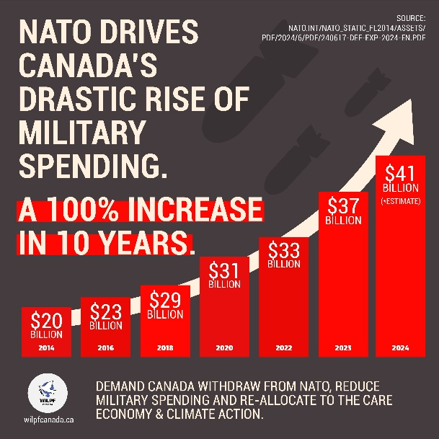

**NO TO 5% GDP. NO to $150 BILLION ON THE MILITARY. CUT MILITARY SPENDING. CANADA OUT OF NATO.**